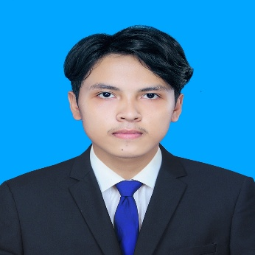
E
Student
DIN RASY
PROFILE
Fourth-year Information and Communication Engineering student at the Institute of Technology of Cambodia with a strong foundation in full-stack web development. Passionate about building innovative software solutions, bringing strong analytical problem-solving, and collaborative skills. Motivated to drive digital innovation and grow professionally under the guidance of experienced developers.
PERSONNAL
- Marital Status Single
- Date of Birth: 26 Dec 2004
- Nationality: Cambodian
- Place of Birth: Battambang

EDUCATION
INSTITUTE OF TECHNOLOGY OF CAMBODIA
SKILLS
2023-present
Bachelor of Information and Communication Engineering
- Communication
- Teamwork
- Time management
- Critical thinking

TECHNICAL SKILLS
- Front End: HTML, CSS, JavaScript, Java(OOP), Vue.js
- Back End: Spring Boot, NestJS, Laravel
- Databases: MySQL, MongoD, PosgreQL
- Tools: Jenkins, Ansible, Docker, Git, Project Collaboration
- Other Skills: Video editing with Capcut
HOBBIES
- Learning New Programming Frameworks
- Coding
- Explore New Thing
- Reading
- Listening

PROJECT EXPERIENCE
CONTACT ME
- Address: Khan Mean Chey
- Tell: 0963020711
- Email: rasydin77@gmail.com

Enrollment Management System (Spring Boot)
- Web system for student enrollment with CRUD and authentication.
Perfume E-Commerce Website (Vue.js)
- Online store with dynamic product display, search, and shopping cart.
Jomnus Website (ជំនួស) (NestJS and Next.js)
- Micro Task platform connecting users with every day or personal requests.

LANGUGE

- Khmer
- English

WORK EXPERIENCE
Restaurant Service Staff – Chrong Baitong

2 years experience
REFEREES
2024-2025
- Provided customer service, handled orders, and maintained a clean and organized workspace.
- Developed teamwork and time management skill in a fast-paced environment.
- Mr. Sam Serei Odam
Manager – Chrong Baitong
Email: Chrongbaitong@gmail.com
Tell: 069924168

Video Editor – Chrong Baitong / Freelance - Present

October 2025
- Edited promotional videos using Capcut, enhancing restaurant marketing materials
- Gained skills in visual communication and content presentation.
COVER LETTER FOR INTERNSHIP

DIN RASY
Information and Communication Engineering Student
Institute of Technology of Cambodia
Phnom Penh, Cambodia
Phone: 0963020711
Email: rasydin77@gmail.com

Date: 05/06/2026

Dear Hiring Manager,

I am writing to apply for the Full-Stack Developer Internship position at Saat R&D Center. I am a fourth-year Information and Communication Engineering student at the Institute of Technology of Cambodia, and I am eager to gain practical experience in full-stack web development.

I am available for a three-month internship starting July 1st to August 31st, 2026. Through my academic training, I have built a solid foundation in HTML, CSS, JavaScript, Vue.js, Next.js, Java(OOP), Spring Boot, NestJS, Laravel, and MySQL. I have also gained practical experience developing web projects, including a student Enrollment Management System, an online Perfume E-Commerce website, and the Jomnus micro-task platform, which strengthened my understanding of full-stack development, database integration, and responsive design.

In addition, my work experience as a restaurant service staff and editor has helped me develop strong teamwork, communication, and time management skills. I am confident that my technical skills, discipline, and enthusiasm will allow me to contribute effectively to your development team and support the creation of innovative web applications.

Thank you very much for considering my application. I would welcome the opportunity to further discuss how I can contribute to your projects while continuing to grow under the guidance of your experienced team.


Sincerely,

DIN RASY

